**Unit 618 Fundamentals of database**

**administration**

# Assessment brief and mapping

**Submission Dates:**

|  |  |
| --- | --- |
| All Tasks |  |

The putrpose of this assessment and markeing scheme is to completment the MTA 98-364 Database Fundamentals

|  |  |  |  |  |  |  |
| --- | --- | --- | --- | --- | --- | --- |
| **Task** |  | **Evidence** |  | **Unit coverage**  **(LO & AC**  **references)** |  | **Grading ref** |
| A, B, C, D, E |  | MTA 98-364 Database Fundamentals |  | 1.1, 1.2, 1.3, 1.4, 1.5  2.1, 2.2, 2.3, 2.4  3.1, 3.2, 3.3, 3.4  4.1, 4.2, 4.3, 4.4. 4.5, 4.6, 4.7, 4.8  5.1, 5.2, 5.3, 5.4, 5.5, 5.6 |  |  |
| F |  | Database correctly created and configured. |  | 6.1, 6.2, 6.3, 6.4 |  |  |

**Unit 618 Fundamentals of database**

**administration**

### Candidate name Candidate number

**Anthony Quinn**

Centre name: Donegal Education and Training Board Centre number

|  |  |  |
| --- | --- | --- |
| **Task** | **Evidence** | **Mark**  Candidate must achieve all sections for a pass |
| **A, B, C, D, E** | **MTA 98-364 Database Fundamentals** |  |
| F | 6 |  |
| Grade | |  |

|  |  |  |
| --- | --- | --- |
| **I can confirm that the evidence listed for this unit is my own work and was carried out under the conditions and context specified in the assessment specification.** | | |
| Candidate signature |  | Date 28th May 2021 |
| I confirm that the candidate has achieved all the requirements of this unit with the evidence listed and the assessment was conducted under the specified conditions and context, and is valid, authentic, reliable, current and sufficient. | | |
| Tutor/assessor signature |  | Date |
| Quality assurance co-ordinator’s signature (where applicable) |  | Date |
| Qualifications consultant signature (where applicable) |  | Date |

Unit 618 Fundamentals of database

Administration

Using evidence from your practice in Database Administration, demonstrate the following:

6.1 Creation of database objects. This should be demonstrated using DDL commands and should include the creation of

6.1.1 Tables

CREATE TABLE tblHousingByCountyAndElectrolDivision2011(

ElectoralCode INT PRIMARY KEY,

ElectoralDivision varchar(30) NOT NULL,

County varchar(20) NOT NULL,

Bungalow_2011 INT NOT NULL,

Flat_2011 INT NOT NULL

);

BULK INSERT tblHousingByCountyAndElectrolDivision2011

FROM 'C:\Users\Client 9.20 SSD\OneDrive\Desktop\Database Fundamentals\ETB_Database_Fundamentals-main\theme_6_2_electoral_divisions.csv'

WITH (

FIRSTROW=2,

FIELDTERMINATOR = ',',

ROWTERMINATOR = '\n',

BATCHSIZE=97

);

The theme_6_2_electoral_divisions.csv file has been attached as a file to this Assessment handup.

6.1.2 Views

CREATE VIEW [HighestVacancyRate] AS

SELECT CountyName,VacancyRate

FROM tblHousingData

WHERE VacancyRate >10

GO

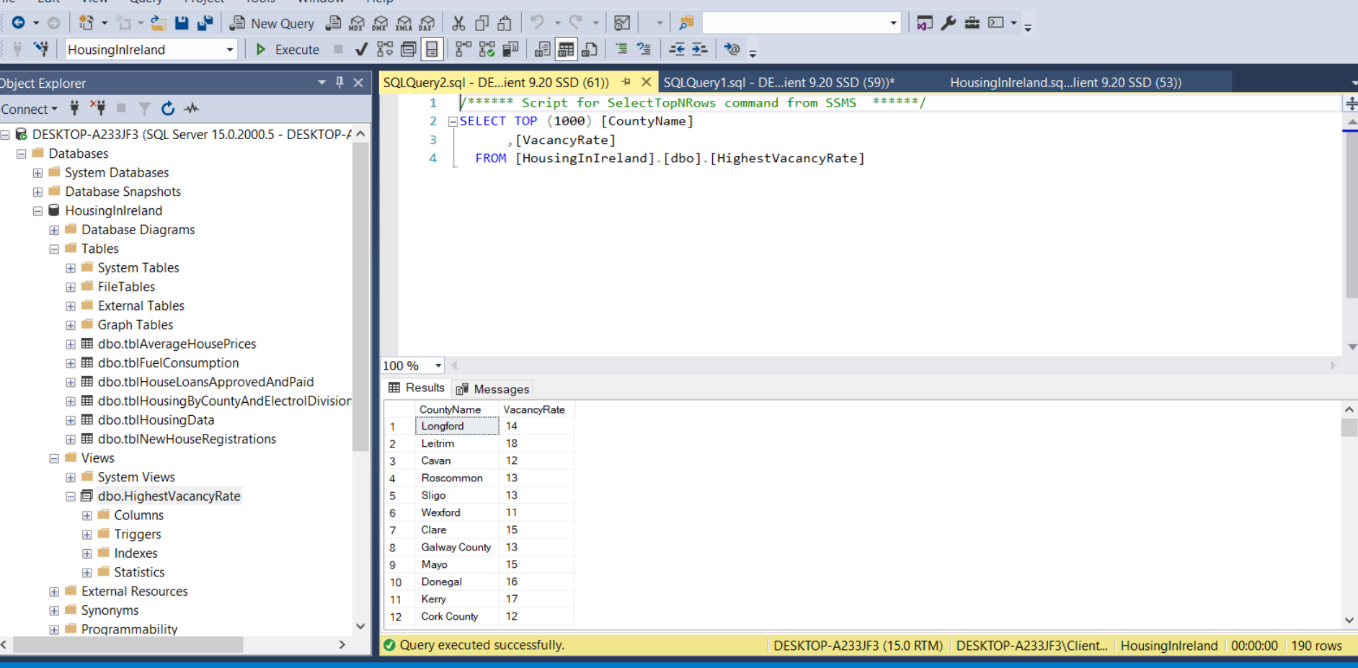

6.1.3 Procedures

CREATE PROCEDURE SPSELECTMAXFUELTYPE

AS

SELECT DISTINCT FuelType FROM tblFuelConsumption

EXECUTE SPSELECTMAXFUELTYPE;

GO

TBC

6.1.4 Functions.

GO

CREATE OR ALTER FUNCTION HousePriceByArea(@Area varchar(30))

RETURNS TABLE

AS

RETURN

SELECT AVG (HouseValue) AS Average_Value FROM tblAverageHousePrices

WHERE tblAverageHousePrices.Area =@Area AND tblAverageHousePrices.SurveyYear = '2000'

GO

SELECT * FROM HousePriceByArea('Galway');

GO

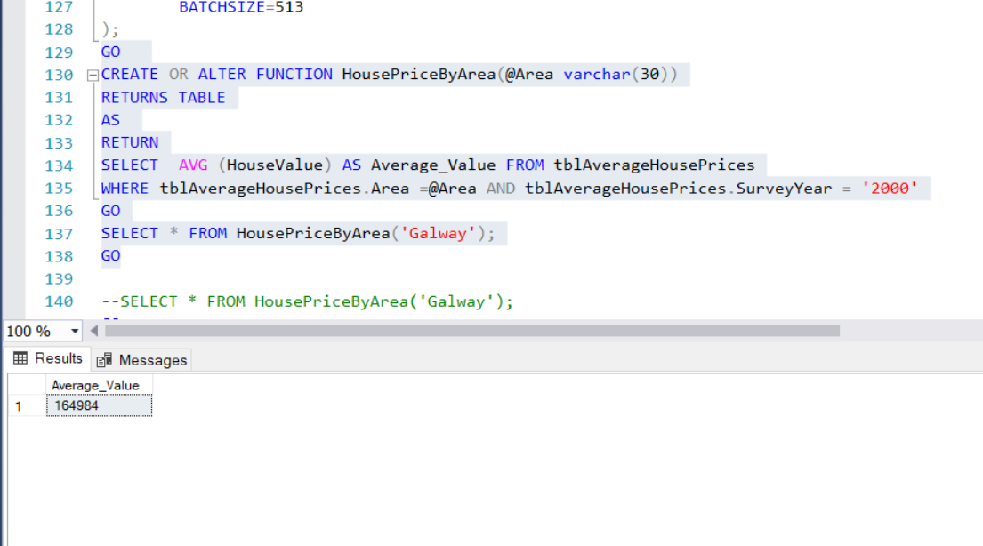

6.2 Demonstrate manipultion of data in the tables through the DML commands like

6.2.1 SELECT

-- 1 List all columns in tblHousingData;

SELECT CensusYear,CountyName,NumberOfUnits, VacancyRate

FROM tblHousingData;

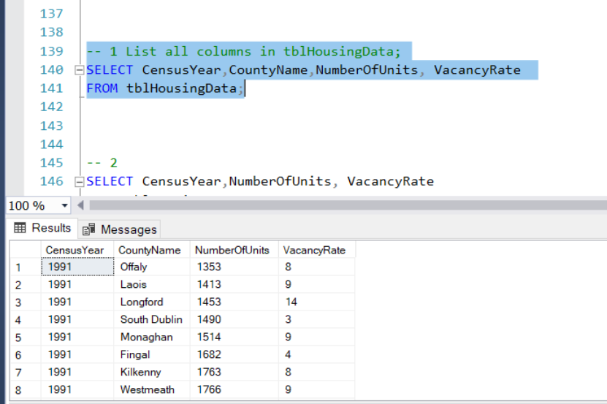

6.2.2 INSERT

INSERT INTO tblHousingByCountyAndElectrolDivision2011(ElectoralCode,ElectoralDivision,County,Bungalow_2011,Flat_2011)

VALUES

(1831,' 199 Does not Exist','Monaghen North ',2000,40000);

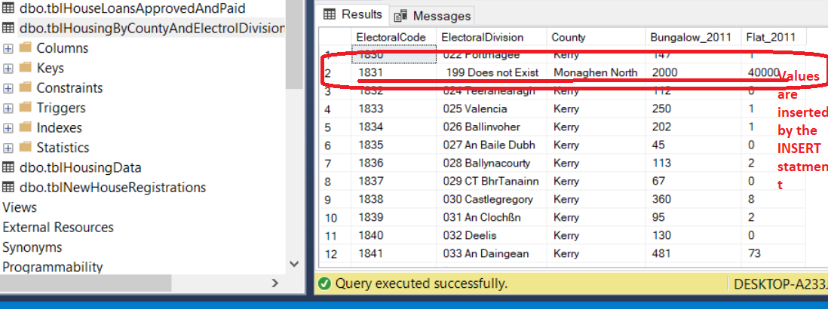

6.2.3 UPDATE

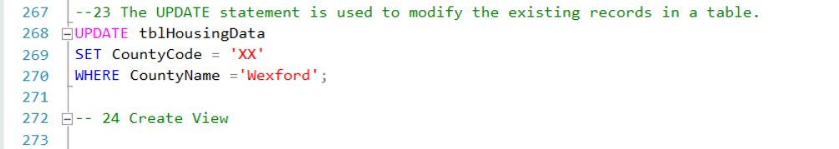

Figure 1 SQL UPDATE Statement

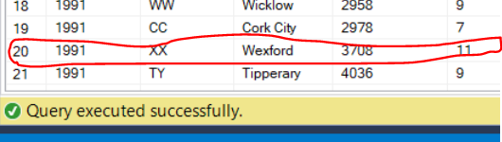

Figure 2UPDATE ststment applied to the tblHousingData table

6.2.4 DELETE

--9 The Electoral Division: 022 Portmagee needs to be removed from the tblHousingByCountyAndElectrolDivision2011 table

DELETE FROM tblHousingByCountyAndElectrolDivision2011 WHERE ElectoralCode = 1830;



Figure 3 Prior to applying the DELETE statement

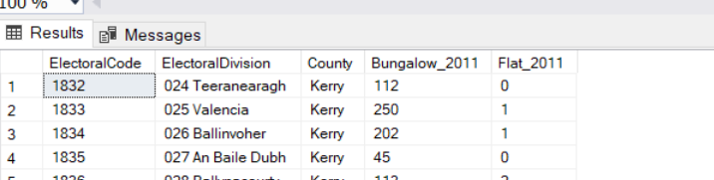

Figure 4 The DELETE statement has removed the Portmagee Electoral Division values.

GO

6.3 Configuring the Database

6.3.1 Normalize the following and show the tables in the 1NF, 2NF and 3NF.

Seperate files, provided with this submission.

Insert table here

6.3.2 Create Primary keys and Foriegn Keys through SSMS designer View and show the realtionship between the tables.

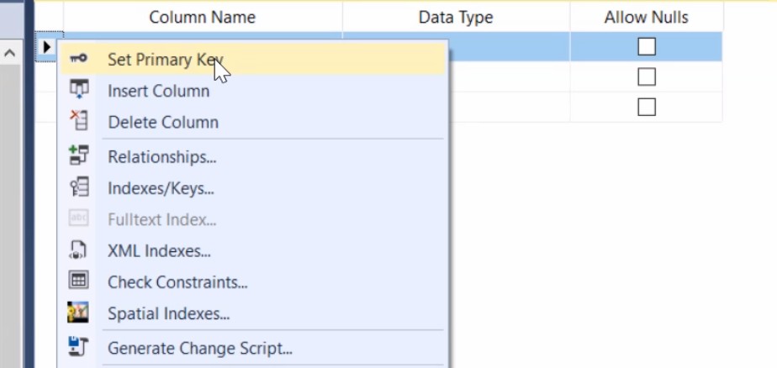

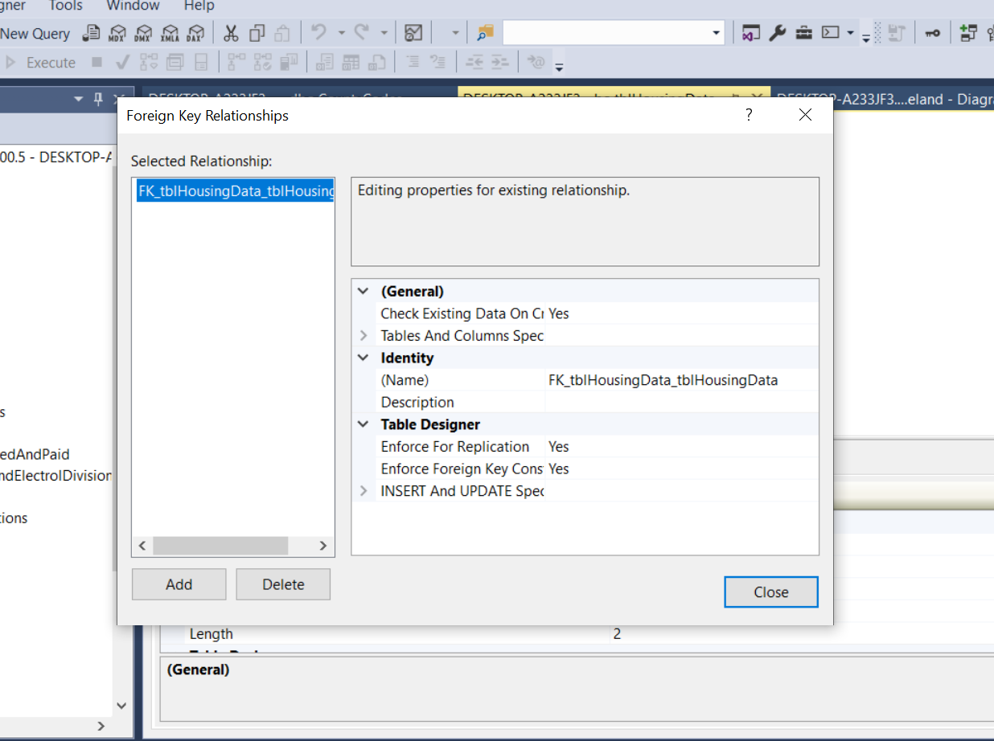

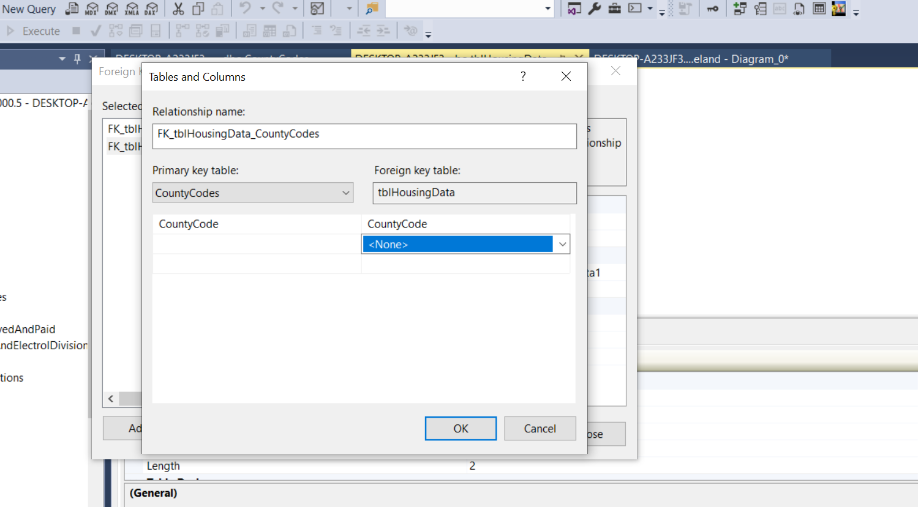

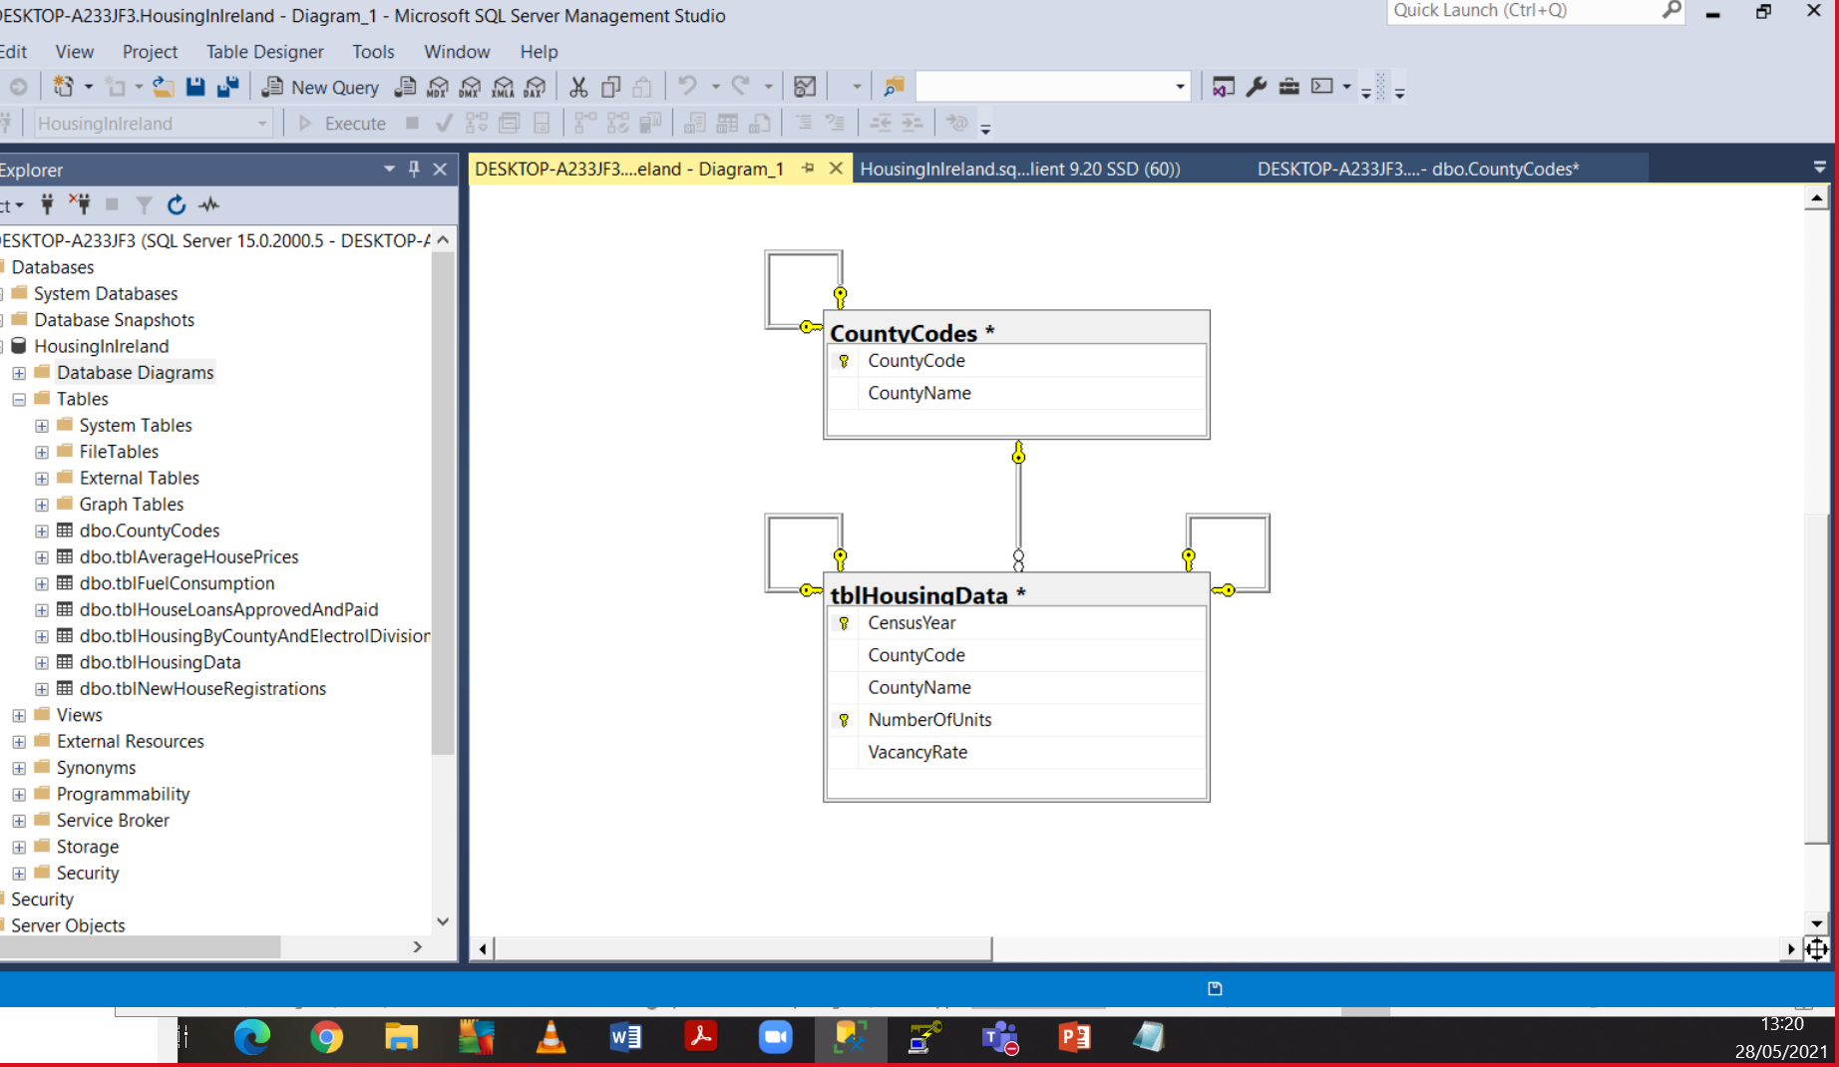

6.3.3 Demonstrate the creation of Clustered and Non-clustered Indexes with the help of SQL commands.

6.4 Implement database security

6.4.1 Create a SQL server Login and demonstrate SQL server Authentication. Assign fixed server role as serveradmin and fixed database role as db_datareader.

6.4.2 Create backup of the database that was created in section 6.1 and set recovery modes and restore the database through SSMS.

**Unit 618 Fundamentals of database**

**Administration**

|  |  |  |
| --- | --- | --- |
|  | Achieved |  |
| 6.1 Creation of database objects.    6.1.1 Tables  Unit 618  6.1.2 Views  CREATE VIEW [HighestVacancyRate] AS  SELECT CountyName,VacancyRate  FROM tblHousingData  WHERE VacancyRate >10  GO  6.1.3 Procedures  6.1.4 Functions. | ( )  ( )  ( )  ( ) | [ ] |
| 6.2 Demonstrate manipultion of data  6.2.1 SELECT  -- 1 List all columns in tblHousingData;  SELECT CensusYear,CountyName,NumberOfUnits, VacancyRate  FROM tblHousingData;  6.2.2 INSERT  INSERT INTO tblHousingByCountyAndElectrolDivision2011(ElectoralCode,ElectoralDivision,County,Bungalow_2011,Flat_2011)  VALUES  (2000,' 199 An Tir Nua','Monaghen North ',2000,40000);  6.2.3 UPDATE  --23 The UPDATE statement is used to modify the existing records in a table.  UPDATE tblHousingData  SET CountyCode = 'XX'  WHERE CountyName ='Wexford';  6.2.4 DELETE  DELETE FROM tblNewHouseRegistrations  WHERE County LIKE 'All Counties%'; | ( )  ( )  ( )  ( ) | [ ] |
| 6.3 Configuring the Database  6.3.1 Normalize the following and show the tables in the 1NF, 2NF and 3NF.  6.3.2 Create Primary keys and Foriegn Keys through SSMS designer View and show the realtionship between the tables.  6.3.3 Demonstrate the creation of Clustered and Non-clustered Indexes with the help of SQL commands. | ( )  ( )  ( ) | [ ] |
| 6.4.2 Create backup of the database that was created in section 6.1 and set recovery modes and restore the database through SSMS. |  | [ ] |
|  | Grade |  |

In order to pass, all () adn all [ ] must be achieved.

**Unit 618 Fundamentals of database**

**Administration**

## Candidate feedback sheet

Candidate name

|  |  |
| --- | --- |
| **Task & date** | **Assessor comments** |
|  |  |

Candidate signature Date

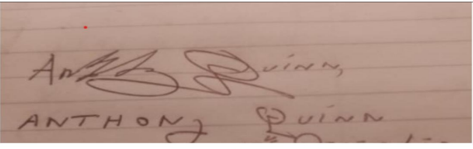 28th May 2021

Tutor/assessor signature Date